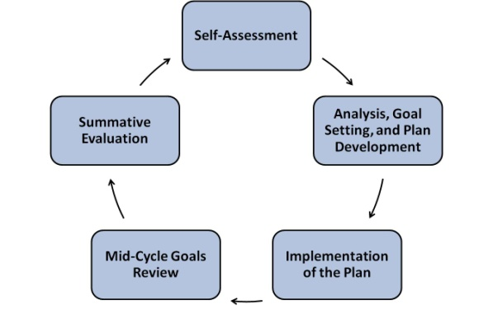
Superintendent Evaluation: the basics
New Superintendent Induction Program, May 2017

- Cycle Step 1: Superintendent’s Self-Assessment
  - Assesses his/her own performance against the Standards & Indicators (not elements)
  - Proposes at least 4 goals for the upcoming year
    - 2-4 District Improvement Goals
    - At least 1 Student Learning Goal
    - At least 1 Professional Practice
  - For each goal, includes key strategies and benchmarks for measuring success
  - Multi-year goals can be appropriate, but they need annual benchmarks
- Cycle Step 2: Analysis, Goal Setting, and Plan Development (public meeting)
  - School Committee & Superintendent review proposed goals together
  - School Committee revises as needed and adopts the annual goals
  - School Committee & Superintendent review the Evaluation Rubric together to identify a modest number of indicators within any Standard that require special focus for the superintendent and weight in the evaluation process in the coming year
- Cycle Step 3: Superintendent Plan Implementation and Collection of Evidence.
  - Superintendent implements the goals
- Cycle Step 4: Mid-Cycle Goals Review (public meeting)
  - Superintendent prepares and presents a report on progress being made on the goals
  - School Committee reviews the report, offers feedback, and discusses progress and possible mid-cycle adjustments with the superintendent.
- Cycle Step 5: End-of-Cycle and Summative Evaluation Reports
  - The superintendent prepares an End-of-Cycle Report for the School Committee
    - Progress made on each goal
    - Performance against each Indicator (not element).
  - Individual Committee members review report and rate the superintendent on goals and Indicators and give their completed Evaluation Form to the Subcommittee Chair
  - The Subcommittee chair compiles ratings and comments and prepares a single Summative Evaluation Report for subcommittee review
  - (In a public meeting): The Subcommittee presents Summative Evaluation Report for discussion & vote by entire School Committee
MASS Guide: Superintendent Evaluation Framework and Forms, May 2017

End-of-Cycle Summative Evaluation Report: Superintendent

Superintendent:
Evaluator:
 | Name | Signature | Date

Step 1: Assess Progress Toward Goals (Complete page 3 first; circle one for each set of goal[s].)
Professional Practice Goal(s) | Did Not Meet | Some Progress | Significant Progress | Met | Exceeded
Student Learning Goal(s) | Did Not Meet | Some Progress | Significant Progress | Met | Exceeded
District Improvement Goal(s) | Did Not Meet | Some Progress | Significant Progress | Met | Exceeded

Step 2: Assess Performance on Standards
 | Unsatisfactory = Performance on a standard or overall has not significantly improved following a rating of Needs Improvement, or performance is consistently below the requirements of a standard or overall and is considered inadequate, or both.  Needs Improvement/Developing = Performance on a standard or overall is below the requirements of a standard or overall but is not considered to be Unsatisfactory at the time. Improvement is necessary and expected. For new superintendents, performance is on track to achieve proficiency within three years.  Proficient = Proficient practice is understood to be fully satisfactory. This is the rigorous expected level of performance.  Exemplary = A rating of Exemplary indicates that practice significantly exceeds Proficient and could serve as a model of practice regionally or statewide. |  | Unsatisfactory | Needs Improvement | Proficient | Exemplary
 | Standard I: Instructional Leadership
 | Standard II: Management and Operations
 | Standard III: Family and Community Engagement
 | Standard IV: Professional Culture

End-of-Cycle Summative Evaluation Report: Superintendent

Step 3: Rate Overall Summative Performance (Based on Step 1 and Step 2 ratings; circle one.)
Unsatisfactory | Needs Improvement | Proficient | Exemplary

Step 4: Add Evaluator Comments
Comments and analysis are recommended for any rating but are required for an overall summative rating of Exemplary, Needs Improvement or Unsatisfactory or Impact on Student Learning rating of high or low.
Comments:

Superintendent’s Performance Goals

Goals should be SMART and include at least one goal for each category: professional practice, student learning, and district improvement.
Check one box for each goal.
Goal(s) | Description | Did Not Meet | Some Progress | Significant Progress | Met | Exceeded
Professional Practice
1
Student Learning
2
District Improvement
3
4
5
6

