School Name:
Date of Completion of the
Visiting Team Components:

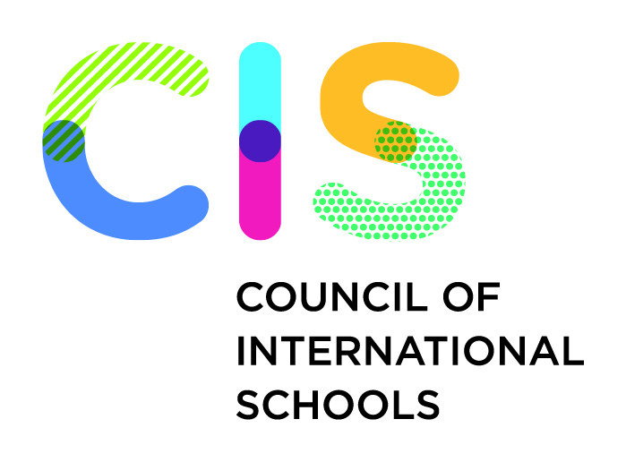
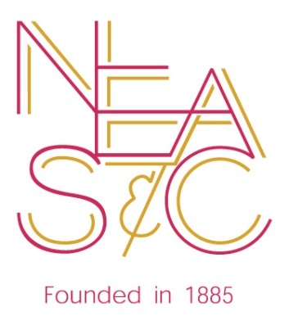

The Reporting Booklet
for
INTRODUCTORY SECTIONS
(FOR COMPLETION BY THE VISITING TEAM ONLY)

First Component – THE TABLE OF CONTENTS

Second Component – THE INTRODUCTION

Third Component – THE PREAMBLE

8th Edition
Version 8.2 - Sept 2014
FIRST COMPONENT- THE TABLE OF CONTENTS

(EACH COMPONENT IS INCLUDED IN SEPARATE REPORTING BOOKLETS THEREFORE THIS TABLE OF CONTENTS SERVES AS A CHECKLIST TO DETERMINE THAT ALL SECTIONS ARE COMPLETE)

Report Name | Insert Check
Introduction
(in Introductory Reporting Booklet)
Preamble
(in Introductory Reporting Booklet)
Visiting Team comments on Part One of the Self Study Report
(Part One Reporting Booklet)
Section A: School Guiding Statements
(Section A Reporting Booklet)
Section B: Teaching and Learning
(Section B Reporting Booklets as appropriate);
Horizontal - Pre-K or similar (if applicable)

Horizontal - Lower School or similar (if applicable)

Horizontal - Middle School or similar (if applicable)

Horizontal - Upper School or similar (if applicable)

Vertical Summary Report

Section C: Governance and Leadership
(Section C Reporting Booklet)
Section D: Faculty and Support Staff
(Section D Reporting Booklet)
Section E: Access to Learning
(Section E Reporting Booklet)
Section F: School Culture and Partnerships for Learning
(Section F Reporting Booklet)
Section G: Operational Systems
(Section G Reporting Booklet)
Team Comments with respect to Part Three of the Self Study
(Part Three Reporting Booklet)
Compiled List of Major Commendations and Recommendations and Concluding Statement
(Concluding Section Reporting Booklet)
List of Team Members
(Concluding Section Reporting Booklet)
SECOND COMPONENT – THE INTRODUCTION

CIS

In July 2003 the Council of International Schools (CIS) took over responsibility for the Accreditation Service which the European Council of International Schools (founded in 1965) had been offering to schools since 1970. CIS is an independent, non-profit, membership organisation of over 660 international schools in approximately 110 countries throughout the world. It serves the interests of some 340,000 young people, a constituency which represents many nationalities with varied cultural, religious, and linguistic backgrounds. CIS also includes universities and colleges to which students from international schools apply.

Presently over 400 CIS member schools have been granted accredited status following a directed comprehensive self-study and a rigorous, thorough evaluation by a Visiting Team, which found them to meet the CIS Standards for Accreditation. Accredited schools are subject to regular monitoring through routine progress reports and visits, and they must undergo a full re-evaluation every ten years. CIS accreditation is accepted throughout the world, including in the USA through membership in good standing of the Commission on Accreditation of the National Association of Independent Schools (NAIS).

The school evaluation programme consists of three main stages: the self-study conducted by the professional staff and other members of the school community, the evaluation by the visiting team, and the follow-up programme carried out by the school under CIS monitoring to implement the findings of the self-study and the valid recommendations of the visiting team.

CIS recognises that schools which are different may be equally good. The fundamental premise of the accreditation programme is that an educational institution must be evaluated in terms of the CIS Standards for Accreditation and the degree to which the school is putting its own Guiding Statements into practice. The school’s Guiding Statements is therefore a vital document, and it should express the principles which guide the governing body, school management and professional staff in their efforts to meet the needs of the students enrolled. The visiting team’s observations on the school’s Guiding Statements are found in Section A of this evaluation report.

As the responsible body for matters of evaluation and accreditation, the CIS Board of Trustees charges visiting teams with the responsibility of assessing the degree to which evaluated schools are putting their own Guiding Statements into practice and the extent to which they are meeting the published Standards for Accreditation.

NEASC

The New England Association of Schools and Colleges (NEASC) is the oldest of the six regional accrediting agencies in the United States. Since its inception in 1885, the Association has awarded accreditation to educational institutions in the six-state New England region that seek voluntary affiliation. In 1980, NEASC agreed to work co-operatively with the European Council of International Schools (ECIS) in serving institutions interested in seeking accreditation with both organizations. This cooperation continued when ECIS transferred responsibility for accreditation services to the Council of International Schools (CIS) in July 2003.

The governing body of the New England Association of Schools and Colleges is its Executive Committee which oversees the work of four commissions: The Commission on Institutions of Higher Education; The Commission on Independent Schools; The Commission on Public Schools, and the Commission on International Education (CIE).

The United States Secretary of Education is required by federal statute to publish a list of accrediting agencies which he determines to be reliable authorities as to the quality of education offered by institutions. The New England Association is on the Secretary’s approved list. In order to achieve this status, the Association was required to submit its policies and procedures to the same rigorous scrutiny which is expected of the Association’s own member institutions during the evaluation process.
THIRD COMPONENT: THE PREAMBLE
(Important Information about the School)

Using the information provided in Part One of the Self Study, and with the assistance of the school over factual matters, the Visiting Team Chair should complete the table below in full.

School Name:
Pechersk School International, Kyiv
School Foundation Date:
1995 by a group of parents on behalf of 47 students
School’s Official Status:
Not for profit, co-educational day school
Facts on School Governance & Management:
12 Member Board of Governors comprised of elected and appointed parents with one member appointed by the US Ambassador. The day to day operations are addressed by the Management Team with two organizational charts; one representing the Educational Leadership and the second representing the Business Departments. The positions on these charts ultimately report to the Director who in turn reports to the Board.
Students: number of nationalities; statistically most important nationalities:
Early Childhood- enrolment includes17 students representing ( ) nationalities with the greatest number Ukrainian (6) and USA (2). Primary School enrolment includes 223 students representing 40 nationalities with the most significant nationalities including Ukrainian (59), USA (49), British (11), Russian and Israeli (8), Sweden (6) and Turkey (5). The Secondary Middle Years Program enrolment totals 153 students representing 31 nationalities with the most predominant including Ukrainian (48), USA (34) and Dutch, British and Israeli (6). The Secondary Diploma Program includes 43 students representing 17 nationalities with Ukrainian and USA each representing (11) students.

School Divisions, Range of Grades or Year-Groups:
Academic Staff: numbers; nationalities; statistically most important nationalities:
Support Staff: numbers; nationalities; statistically most important nationalities:
Summary of Academic Programmes:
Location and Buildings:
Accreditation History of the School:
Other Relevant Information about the school (if any):
Concise comments about the School’s Self Study Process:
Concise comments about the Team Visit:
Acknowledgements:

