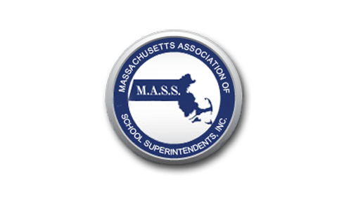

September 8, 2020

Dear Editor:

The controversy surrounding the reopening plan for the Newton Public Schools mirrors a phenomenon playing out across the Commonwealth. Faced with incredibly complex decisions about reopening schools, Superintendent David Fleishman and the Newton School Committee – like their counterparts throughout Massachusetts – find themselves in a truly “no-win” situation. For months, they’ve been exploring countless options, seeking a path that is best for students. Parents and staff who oppose reopening school buildings, even with extensive health and safety precautions, clamor for full remote learning. Others concerned about the shortcomings of distance learning insist families should have the option for some in-person learning, with all the necessary protocols in place. District leaders listened closely to all sides, but ultimately had to choose a course of action, knowing they cannot satisfy everyone.

Newton and many other districts first adopted a hybrid model, combining in-person and distance learning, reflecting the preference of a majority of parents surveyed. Yet the leadership of state and some local teachers’ unions, dismayed that district officials have not bowed to political pressure and scare tactics, retaliate by urging teachers not to report to required training sessions, or in the case of Newton and Andover, take a very public “vote of no confidence” in the Superintendent. How unfortunate that in these profoundly challenging circumstances, when thoughtful, principled leaders are working nearly around the clock to do what is best for students, these union leaders resort to the same-old intimidation tactics simply because they did not get their way.

We are immensely proud of School Committees and Superintendents across the Commonwealth for providing sound, decisive leadership during these turbulent times. We stand by our members who continue to face resistance and insulting rhetoric from union leaders who would rather criticize than compromise.

